Lab#9 (11th Week):

Strings and Structs
Name | Nneoma Onwe
Date | 17/12/2023

Exercise 1:
Code
#include <stdio.h>
#include <string.h>

int main() {
char fullname[80]; // declare character array fullname of size 80

// Display the size of the name array using the sizeof() function
printf("Size of fullname array: %lu\n", sizeof(fullname));

// Ask the user to input his or her first name and second name
printf("Enter your first name and last name: ");
fgets(fullname, sizeof(fullname), stdin);

// Compute the length of the string stored in fullname array using the strlen() function
int length = strlen(fullname);
printf("Length of fullname string: %d\n", length);

// Check if the user's name is "Mary Dee" using the strcmp() function
if (strcmp(fullname, "Mary Dee\n") == 0) {
// Display a greeting message using the user's first name only
char firstName[80];
sscanf(fullname, "%s", firstName);
printf("Hello, %s!\n", firstName);
}

return 0;
}

Results:
What happened when you ran the program? Paste screen capture here showing the program being run.
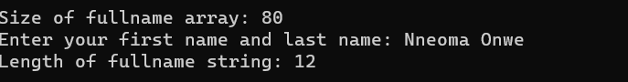

Comment on the exercise:
List the main learning point of this exercise:

Exercise 2:
Code
#include <stdio.h>
#include <string.h>

int main()
{
int array_size = 7;
int i, studentnum[array_size], marks[array_size];
char studentlet[array_size];
float average = 0, sum = 0;

FILE *fptr;
fptr = fopen("studentMarks.txt", "r");

if(fptr != NULL)
{
for(i=0; i<array_size; i++)
{
fscanf(fptr, "%c%5d\t%d\n", &studentlet[i], &studentnum[i], &marks[i]);
sum += marks[i];
printf("%c%5d\t%d\n", studentlet[i], studentnum[i], marks[i]);
}
fclose(fptr);
}
else
{
printf("ERROR - can't open file\n");
return 1;
}

average = sum/array_size;
printf("Average marks = %.2f", average);
return 0;
}

Results:
What happened when you ran the program? Paste screen capture here showing the program being run.

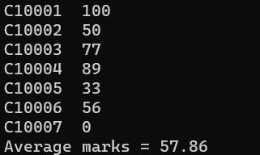

Comment on the exercise:
List the main learning point of this exercise:

Exercise 3:
Code
#include <stdio.h>
#include <string.h>

// Define the structure StudentRecord
struct StudentRecord {
char name[80];
int id;
float averageMark;
char programme[80];
};

int main() {
// Declare two structure variables
struct StudentRecord student1;
struct StudentRecord student2;

// Input values for student1
printf("Enter the name of student1: ");
fgets(student1.name, sizeof(student1.name), stdin);
printf("Enter the ID of student1: ");
scanf("%d", &student1.id);
printf("Enter the average mark of student1: ");
scanf("%f", &student1.averageMark);
getchar(); // Clear the newline character from the input buffer
printf("Enter the programme of student1: ");
fgets(student1.programme, sizeof(student1.programme), stdin);

// Input values for student2
printf("Enter the name of student2: ");
fgets(student2.name, sizeof(student2.name), stdin);
printf("Enter the ID of student2: ");
scanf("%d", &student2.id);
printf("Enter the average mark of student2: ");
scanf("%f", &student2.averageMark);
getchar(); // Clear the newline character from the input buffer
printf("Enter the programme of student2: ");
fgets(student2.programme, sizeof(student2.programme), stdin);

// Compare the marks and display the result for student1
if (student1.averageMark > 40) {
printf("%s is passing.\n", student1.name);
} else {
printf("%s is not passing.\n", student1.name);
}

// Compare the marks and display the result for student2
if (student2.averageMark > 40) {
printf("%s is passing.\n", student2.name);
} else {
printf("%s is not passing.\n", student2.name);
}

return 0;
}

Results:
What happened when you ran the program? Paste screen capture here showing the program being run.

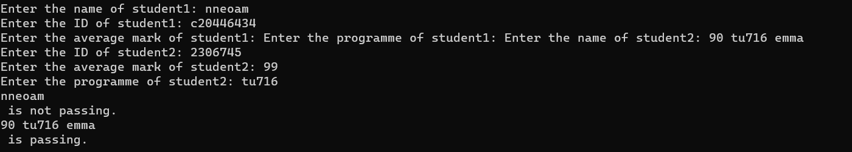

Comment on the exercise:
List the main learning point of this exercise:

